Hear from a caring volunteer 3 – 7 days a week . . .

Become a CONTACT Reassurance Client!

Caring volunteers are available to call you the same time each day

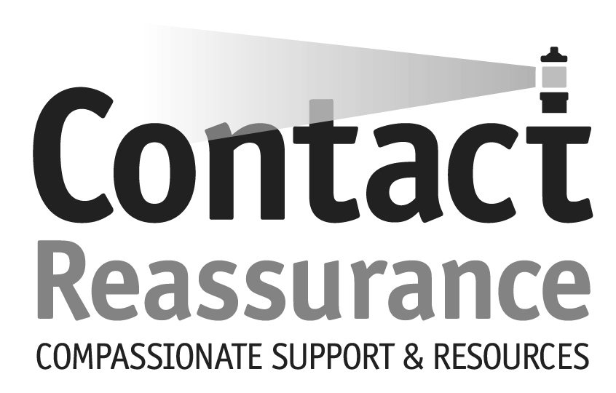

CONTACT is looking for elders and/or disabled in our

community who need someone to reach out to them . . .

to share a few minutes of friendly conversation . . .

to ensure well being . . .

to provide compassionate support . . .

who would appreciate hearing from a caring person

who will really listen!

ARE YOU THAT SOMEONE? Let us help ...

Call our 24/7 Helpline – 856-234-8888
Ask about the Reassurance Program
Helpline Volunteers are available all day, every day

Call our Reassurance Director – 856-234-5484 Ext 212
Visit our Website – www.contactburlco.org

